Canyon Lake Middle School Spirit Wear order form

Student Name: ________________________1st Period Teacher: _____________________

Sweatshirts $25
Youth Large | Adult Small | Adult Medium | Adult Large | Adult XL | TOTAL

Sweatpants (Same logo from Sweatshirt) $20
Youth Large | Adult Small | Adult Medium | Adult Large | Adult XL | TOTAL

Capri Leggings $30
Youth Small | Youth Medium | Youth Large | Youth XLarge | Total
Adult Small | Adult Medium | Adult Large | Adult XLarge | Total

Socks $15
Y: 4-5 Small: 6-8 Medium: 8-10, Large 10-12 Total
Black or White (Please circle)

Total Items ordered: ____________ Amount attached:____________________
Checks or Cash & Order form due to the Bookkeepers window
*Please makes checks payable to CLMS ASB Due February 15th
All sweatshirts are black, Socks you have the choice of Black or White.
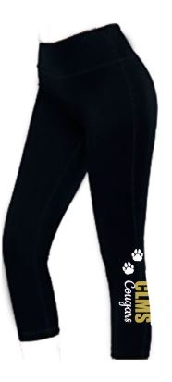
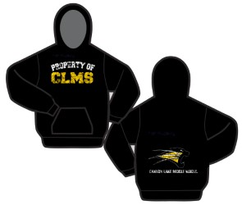
Sweats Leggings Socks
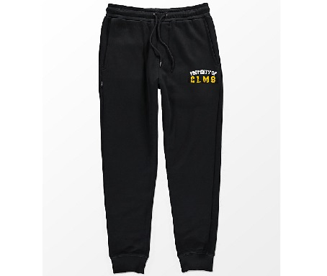
Sweats

